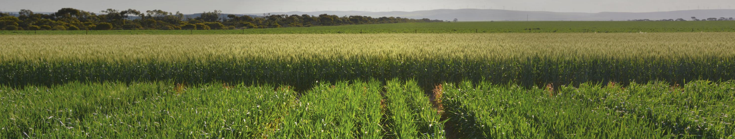
5 Year Long Term Plot Trials Belfrayden NSW
The Belfrayden trial has been carried out over the past 5 years. Each treatment was continuously applied to the same plot for 5 years with a typical broadacre rotation each year. Over the 5-year period, the trial was exposed to many adverse climatic conditions, experiencing double the average rainfall in one season and half the average rainfall in another.

The trial brief was to reduce Agro fertilisers by supplementing with Worm Granules. The trial design was simple, comprising of only up front applications of base fertiliser at sowing. There was no further nutrition applied post seeding. Management of weeds and pathogens were applied as needed and across all plots.

The cost analysis is calculated using current fertiliser pricing and average commodity prices (Dated March 2025).

Trial details 2020 Barley
Rainfall 512mm for the year and 260mm for the growing season May to October.
Sown in mid-May

Wheat 2020 results show Worm Granule at 550kg with no other inputs produced the highest yield, while MAP and Urea returned the greatest gross profit.
It was interesting that 50kg of Urea removed and replaced with 75kg Worm Granule resulted in similar yield and profitability as conventional applications of 100kg Urea.

Trial details 2021 Barley
Rainfall 696.4mm for the year and 224.6mm for the growing season May to October.
Sown in mid-May

Barley 2021 results show MAP 50kg and Urea 50kg returned the highest yield and the greatest gross profit.
It was interesting that 150kg of Worm Granule almost replaced 100kg of Urea in yield and profit. Moreover, when 50kg of Urea was removed and replaced with 75kg Worm Granule it resulted in similar yield and profitability as conventional applications of 100kg Urea.

Trial details 2022 Faba Bean
Rainfall 890.4mm for the year and 425.8mm for the growing season May to October.
Sown in early June

Faba Bean 2022 results showed 150kg Worm Granule with 50kg of MAP and Urea resulted in the highest yield and the greatest gross profit. However, this was closely followed by 75kg Worm Granule with 50kg of MAP.
This was a perfect season for beans; however, it was difficult to harvest with higher-than-average spring rain.

Trial details 2023 Wheat
Rainfall 575mm for the year and 153.2mm for the growing season May to October.
Sown in early May

Wheat 2023 results show MAP 50kg and Urea 100kg returned the highest yield and the greatest gross profit.
It was observed that extra Nitrogen didn’t result in greater yield and that 75kg or 150kg of Worm Granule managed similar yields with only 50kg of Urea.

Trial details 2024 Barley
Rainfall 377.6mm for the year and 175.6mm for the growing season May to October.
Sown in mid-May

Barley 2024 results show 75Kg Worm Granule with 50kg MAP and Urea returned the highest yield, while 50kg MAP and Urea resulted in the greatest gross profit.
It was again observed that extra Nitrogen didn’t result in greater yield and that 75kg or 150kg of Worm Granule managed greater yields and gross profit with 50kg of Urea, compared to applications with 100kg or 150kg of Urea.

Over the Belfrayden 5-year trial there were many different seasons experienced. It was evident that 50kg of MAP and Urea (28kg Nitrogen and 11kg Potassium) was the base fertiliser rate required for the best yield and performance. It was demonstrated that even in years with greater potential increased Nitrogen did not always result in greater yields. It was also observed that when Worm Granule was added to this minimum nutrient application, it increased efficiency of those nutrients. This resulted in the consistent yields and performances in a range of conditions.

The trial was designed to showcase the upfront application of base nutrients with and without Worm Granule. Overall, yields would have been greater with in-crop applications of Nitrogen and potentially demonstrated further benefits of applied Worm Granule to help capture and utilise that applied Nitrogen.

There is no doubt that Worm Granule was increasing nutrient use efficiency beyond the base fertiliser application of 28kg Nitrogen and 11kg Potassium. It was noted that no Nitrogen application had overall yield penalties and with four cereal crops and only one legume, the soil Nitrogen was being depleted. More importantly, the reduction of Nitrogen during the legume season resulted in good outcomes when Worm Granule was supplied.

In conclusion, additions of 50-100kg Worm Granule resulted in the greatest efficiency use of minimum base fertiliser.

